Assignment Report

**for**

Grid layout and Responsive

By Nikit Vaswani

A00258753

**Table of Contents**

Table of Contents i

1. Introduction 2

2. Design 2

3. Snapshots 2

4. Explanation 10

5. Reflection 11

# Introduction

This assignment demanded me to study and research about Grid Layout and Media Queries. I learnt more about creating a responsive website and how Grid Layouts work. Grid Layout has been introduced a couple of years ago.

I had never used Grid Layout before, this assignment gave me a good entry point to Grid Layout.

# Design

For the theme of this design, I choose to have a space inspired design, I have created different divisions using grid, which are head, nav, main, aside and footer and to implement the calculator I used a combination of Table and Eval method provided by JavaScript. I also used JQUERY just to show a change effect in the right-most div.

# Snapshots

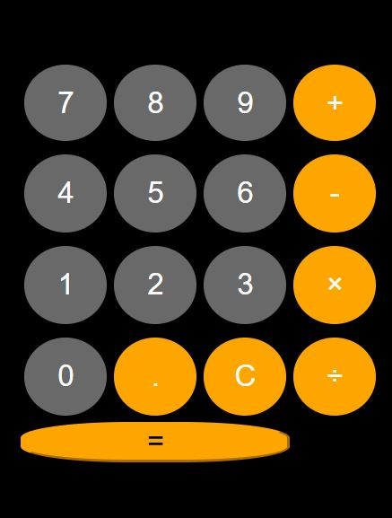



Mobile Snapshots: **Iphone 6/7:** 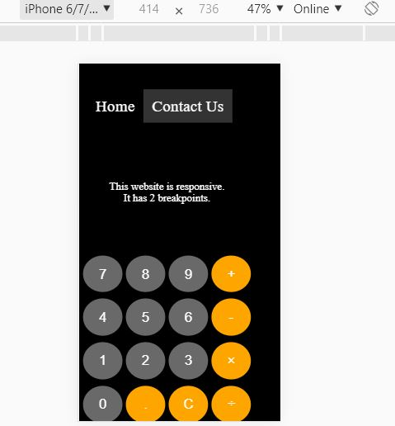

**IPad Pro:**

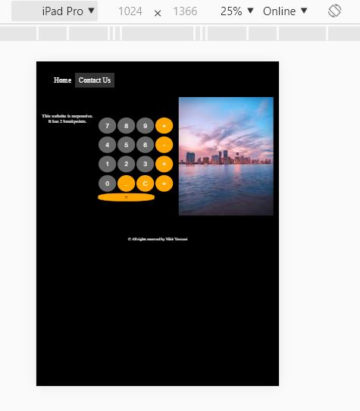

# Explanation:

1. **Grid Layout:** Grid Layout gives us a method of creating grid structures that are described in CSS and not in HTML. It helps us to create layouts that can be redefined using Media Queries and adapt to different contexts. Grid Layout lets us properly separate the order of elements in the source from their visual presentation. As a designer this means you are free to change the location of page elements as is best for your layout at different breakpoints and not need to compromise a sensible structured document for your responsive design.
2. **Responsive Design:** Responsive Web design is the approach that suggests that design and development should respond to the user’s behavior and environment based on screen size, platform and orientation.
3. **Media Queries:** Media query is a CSS technique introduced in CSS3. It uses the @media rule to include a block of CSS properties only if a certain condition is true. It helps in implementing Responsive Web Design.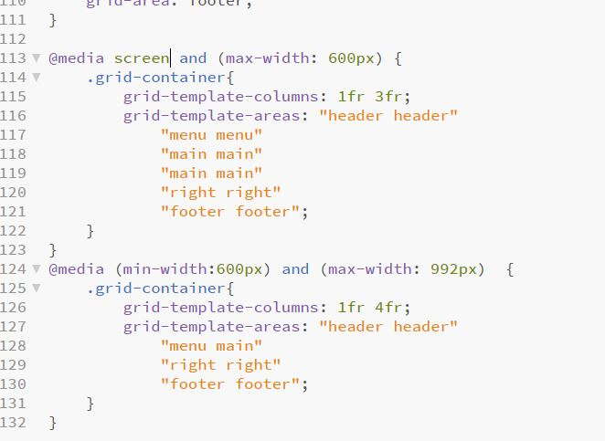

Here as you can see I have used Media Query at the minimum width of 768px, to handle the rows and columns of the grid, I have given specific width to the columns and given auto to rows which indicates to adjust according to the screen size.

I also used, meta tag to handle the viewport,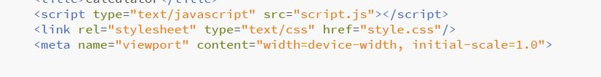

A <meta> viewport element gives the browser instructions on how to control the page's dimensions and scaling.

The width=device-width part sets the width of the page to follow the screen-width of the device (which will vary depending on the device).

The initial-scale=1.0 part sets the initial zoom level when the page is first loaded by the browser.

# Reflection:

I learnt a lot doing this assignment, Grid Layout was new and exciting, and also I learnt how important it is to make designs responsive in today’s age where user’s access websites from various devices and not all devices have same resolutions. I would try to make more websites like this to help me practice.